**Name: Sreelakshmi R**

**Roll No:41**

**Batch: RMCA S3B**

**Date:01-09-2022**

**DATA SCIENCE LAB**

**Experiment No.: 2**

**Aim**

1.Histogram

2.Distribution Chart

3.Scatter Plot

4.Bubbble Chart

**Procedures**

**1.Histogram**

import matplotlib.pyplot as plt

import numpy as np

# Use numpy to generate a bunch of random data in a bell curve around 5.

n = 5 + np.random.randn(1000)

m = [m for m in range(len(n))]

plt.bar(m, n)

plt.title("Raw Data")

plt.show()

plt.hist(n, bins=20)

plt.title("Histogram")

plt.show()

plt.hist(n, cumulative=True, bins=20)

plt.title("Cumulative Histogram")

plt.show()

**Output Screenshot**

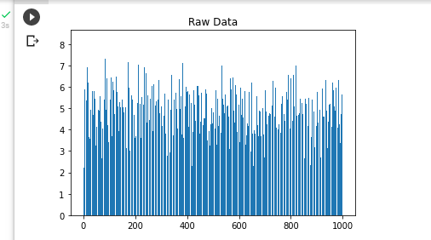

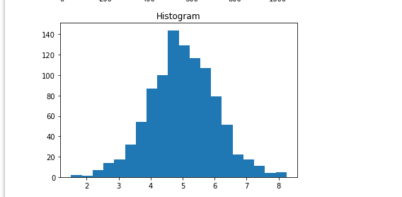

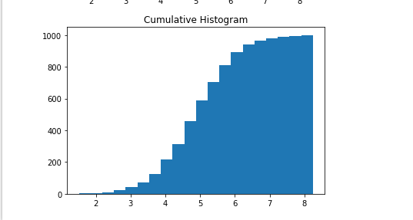

**2.Distribution Chart**

# import the necessary libraries

import seaborn as sns

import matplotlib.pyplot as plt % matplotlib inline

# to ignore the warnings

from warnings import filterwarnings

# load the dataset

df = sns.load_dataset('tips')

# the first five entries of the dataset

df.head()

**Output Screenshot**

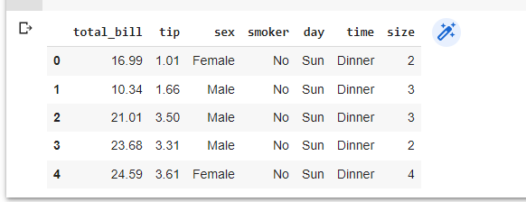

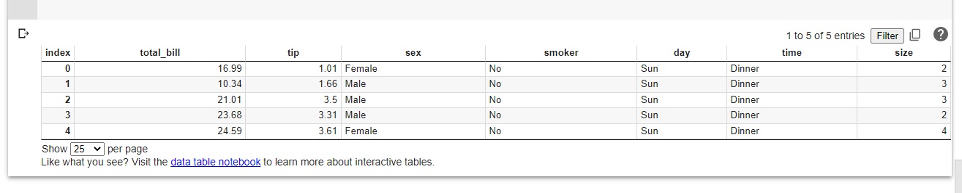

**3.Scattter Plot**

import matplotlib.pyplot as plt

x1 = [2, 3, 4]

y1 = [5, 5, 5]

x2 = [1, 2, 3, 4, 5]

y2 = [2, 3, 2, 3, 4]

y3 = [6, 8, 7, 8, 7]

# Markers: <https://matplotlib.org/api/markers_api.html>

plt.scatter(x1, y1)

plt.scatter(x2, y2, marker='v', color='r')

plt.scatter(x2, y3, marker='^', color='m')

plt.title('Scatter Plot Example')

plt.show()

**Output Screenshot**

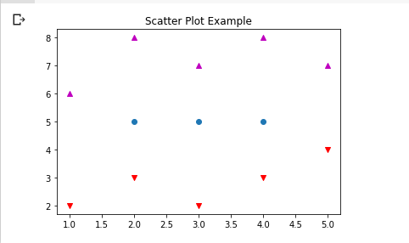

**4.Bubble Chart**

import matplotlib.pyplot as plt

import numpy as np

# create data

x = np.random.rand(40)

y = np.random.rand(40)

z = np.random.rand(40)

colors = np.random.rand(40)

# use the scatter function

plt.scatter(x, y, s=z*1000,c=colors)

plt.show()

**Output Screenshot**

